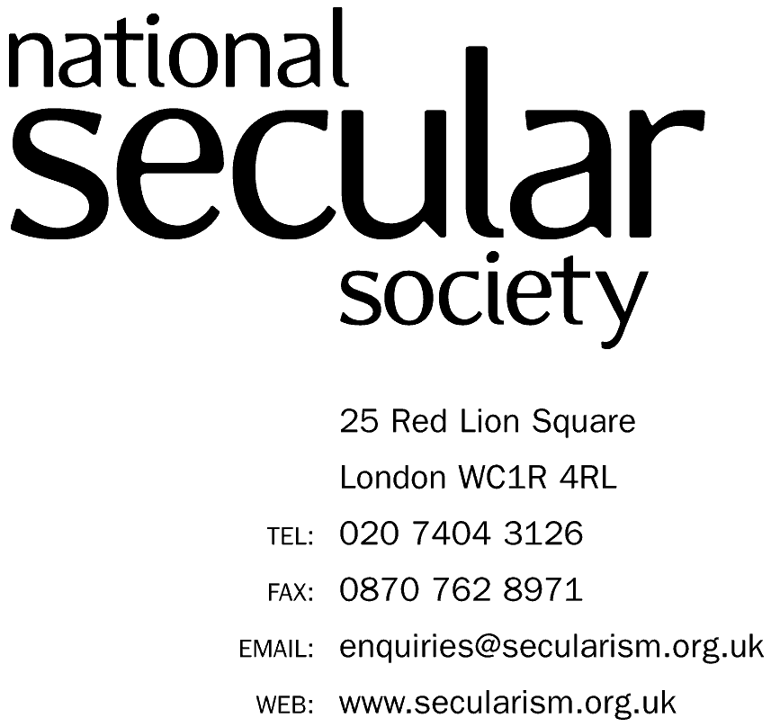

December 20th 2017

BBC Complaints
PO Box 1922
Darlington. DL3 0UR

Dear BBC Complaints,

BBC Radio 4 Today, broadcast 14/12/2017

I am writing on behalf of the National Secular Society to register an official complaint regarding the December 14th 2017 broadcast of the Today programme on BBC Radio 4. We believe that this show, which was broadcast from the Church of England headquarters at Lambeth Palace, and devoted approximately a third of its content to slots effectively promoting the Church of England, did not meet the BBC’s own editorial guidelines regarding impartiality and the treatment of religion. We therefore seek the BBC’s justification for deciding to hold the Today show in this format.

The Church of England is not uncontroversial. Its political role is highly contested. In recent weeks it has been severely criticised for its response to the victims of sexual and physical abuse by its clergy and the institution’s handling of sex abuse is the subject of the ongoing official Independent Inquiry.

Considering the controversial nature of the Church of England, it is inappropriate that the BBC would devote approximately 1 hour of the 3 hour show to content promoting the Church, broadcast from its own HQ. As the data gathered in the attached Appendix reveals, this content frequently portrayed the Church in a positive light, with no opposing, critical views given. While representatives of the Church were given ample space to promote their views and agendas, absolutely no reference was made of the sex abuse scandals or other controversies surrounding the Church. This is in breach of the BBC’s editorial guidelines regarding impartiality, particularly points 4.4.1, 4.4.2, and 4.4.7.

Our analysis of the show also highlighted specific points that breach particular items of the BBC’s editorial guidelines. Details are given in the Appendix. Points we have raised include the praise of the rise of Anglicanism in Africa; a lack of engagement with the irreligious public; giving a voice to those who oppose female Bishops and marriage equality without these views being challenged; and interview questions to Justin Welby demonstrating a bias against the non-religious. An example of this bias was demonstrated by Nick Robinson, who opened a question to the Archbishop with the statement, “…it seems to me now more than ever people look to the church, they look to the leader of the Anglican church, for hope.” Where is the evidence for such an assertion? The declining church attendance figures in the UK in fact suggest the opposite is true.

The prevailing effect of this broadcast of Today was to act as PR exercise for the Church of England. The BBC should not allow itself to be an agent of the Church’s self-promotion agenda. The bias and deference towards the Church of England demonstrated in this show suggests a ‘cosy relationship’ has developed between the BBC and the Church, which undermines public confidence in the BBC’s commitment to impartiality.

I would like the BBC to offer an explanation as to why it considered it appropriate to devote one-third of the Today programme to the promotion of the Church of England, and its justification for flouting its own Editorial Guidelines in the content of the programme regarding impartiality.

Yours sincerely

Stephen Evans, CEO

